**DAILY ONLINE ACTIVITIES SUMMARY**

|  |  |  |  |  |  |  |  |  |
| --- | --- | --- | --- | --- | --- | --- | --- | --- |
| **Date:** | **28/05/2020** | | | | | **Name:** | **Archana J C** | |
| **Sem & Sec** | **4th**  **‘A’** | | | | | **USN:** | **4AL18CS011** | |
| **Online Test Summary** | | | | | | | | |
| **Subject** | | **Microprocessor and embedded system, Aadalitha kannada** | | | | | | |
| **Max. Marks** | | **20, 50** | | **Score** | | | **16, 36** | |
| **Certification Course Summary** | | | | | | | | |
| **Course** | **Introduction to IOT** | | | | | | | |
| **Certificate Provider** | | | **No certificate** | | **Duration** | | | **3hours** |
| **Coding Challenges** | | | | | | | | |
|  | | | | | | | | |
| **Status: Completed** | | | | | | | | |
| **Uploaded the report in Github** | | | | | **Yes** | | | |
| **If yes Repository name** | | | | | **archana_j_c** | | | |
| **Uploaded the report in slack** | | | | | **Yes** | | | |

Online Test Details: (Attach the snapshot and briefly write the report for the same)

The online test is from Microprocessor and embedded system module 2.The test was conducted for 20 marks, duration is 40 minutes. I was scored 16/20.

And the test all from aadalitha kannada all chapters, and the test was conducted for 50 marks, duration is 50 minutes. I was scored 36/50

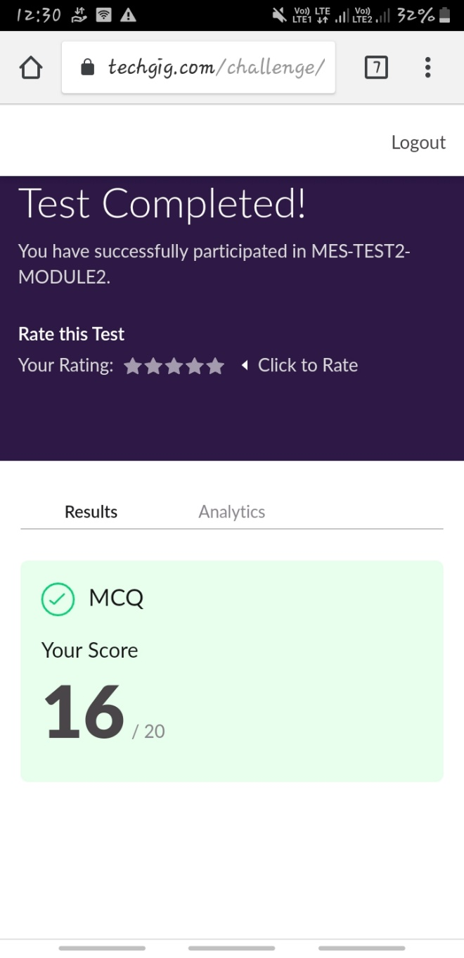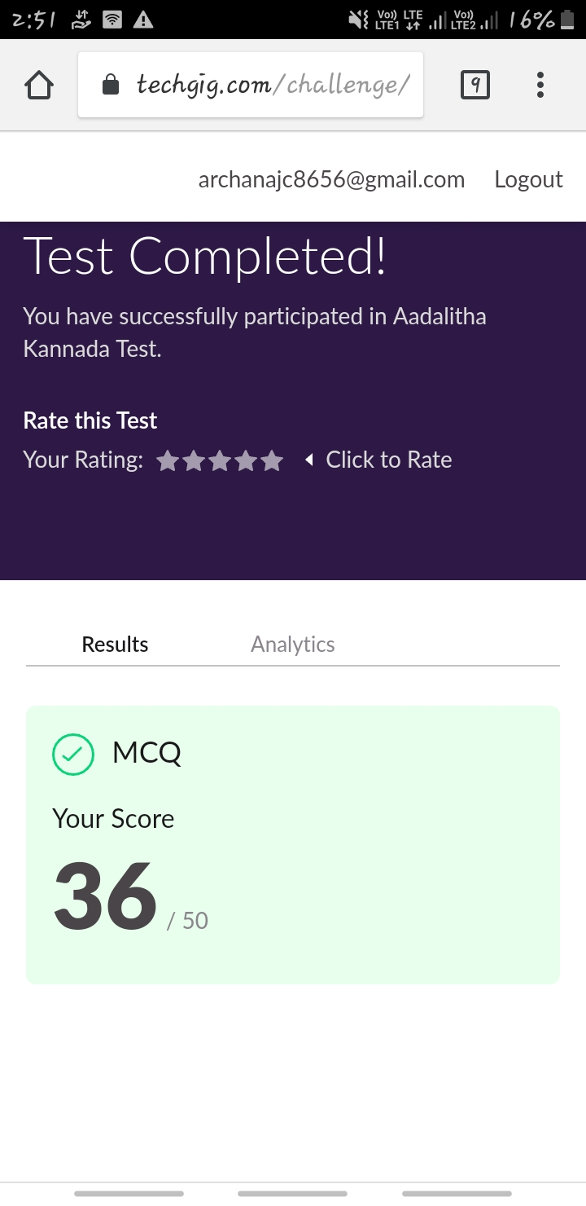

Certification Course Details: (Attach the snapshot and briefly write the report for the same)

COURSE NAME : Introduction to IOT

CERTIFICATION PROVIDERS : Alison

Today I leant about the introduction to IOT, history IOT, Microsoft azure etc…

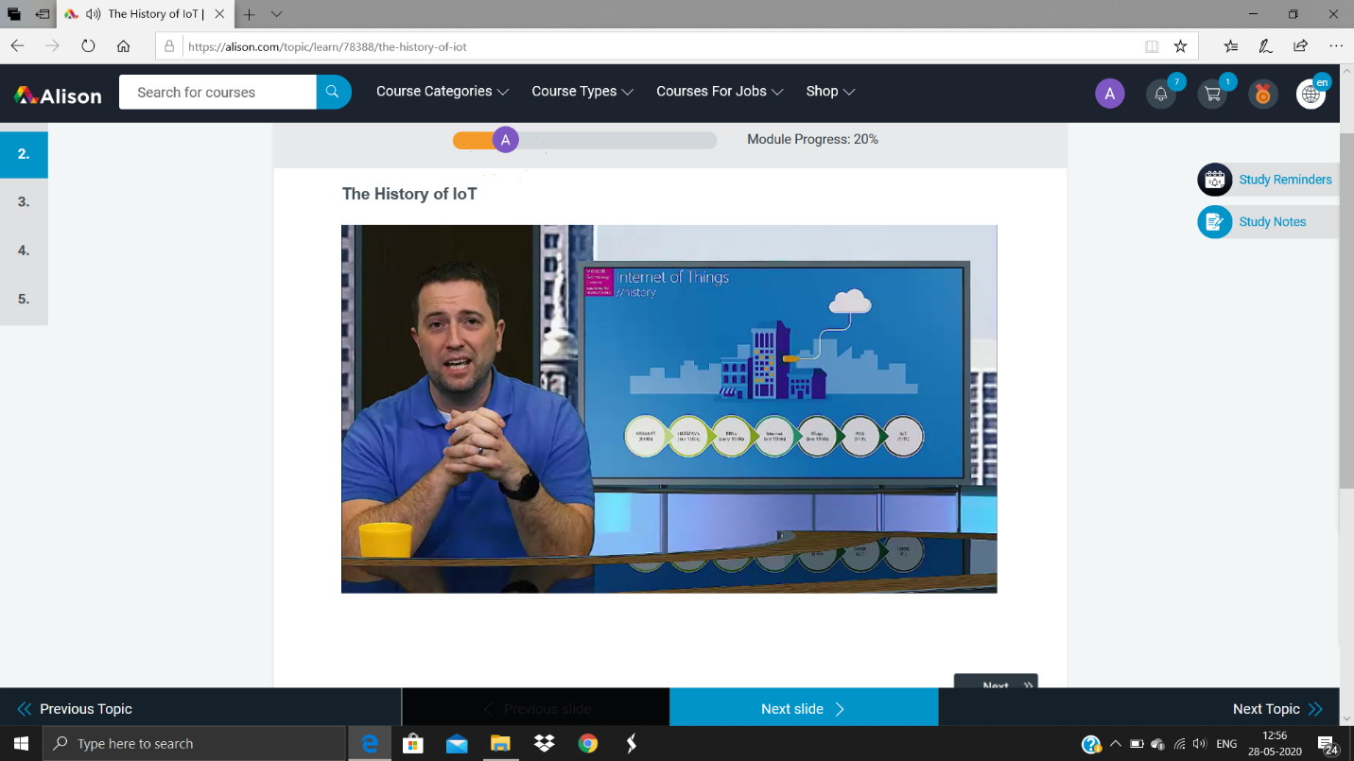

Coding Challenges Details: (Attach the snapshot and briefly write the report for the same)

**Online Coding Details:**

**Problem 1: (using C language) Write a program to print the digital root of a number.**

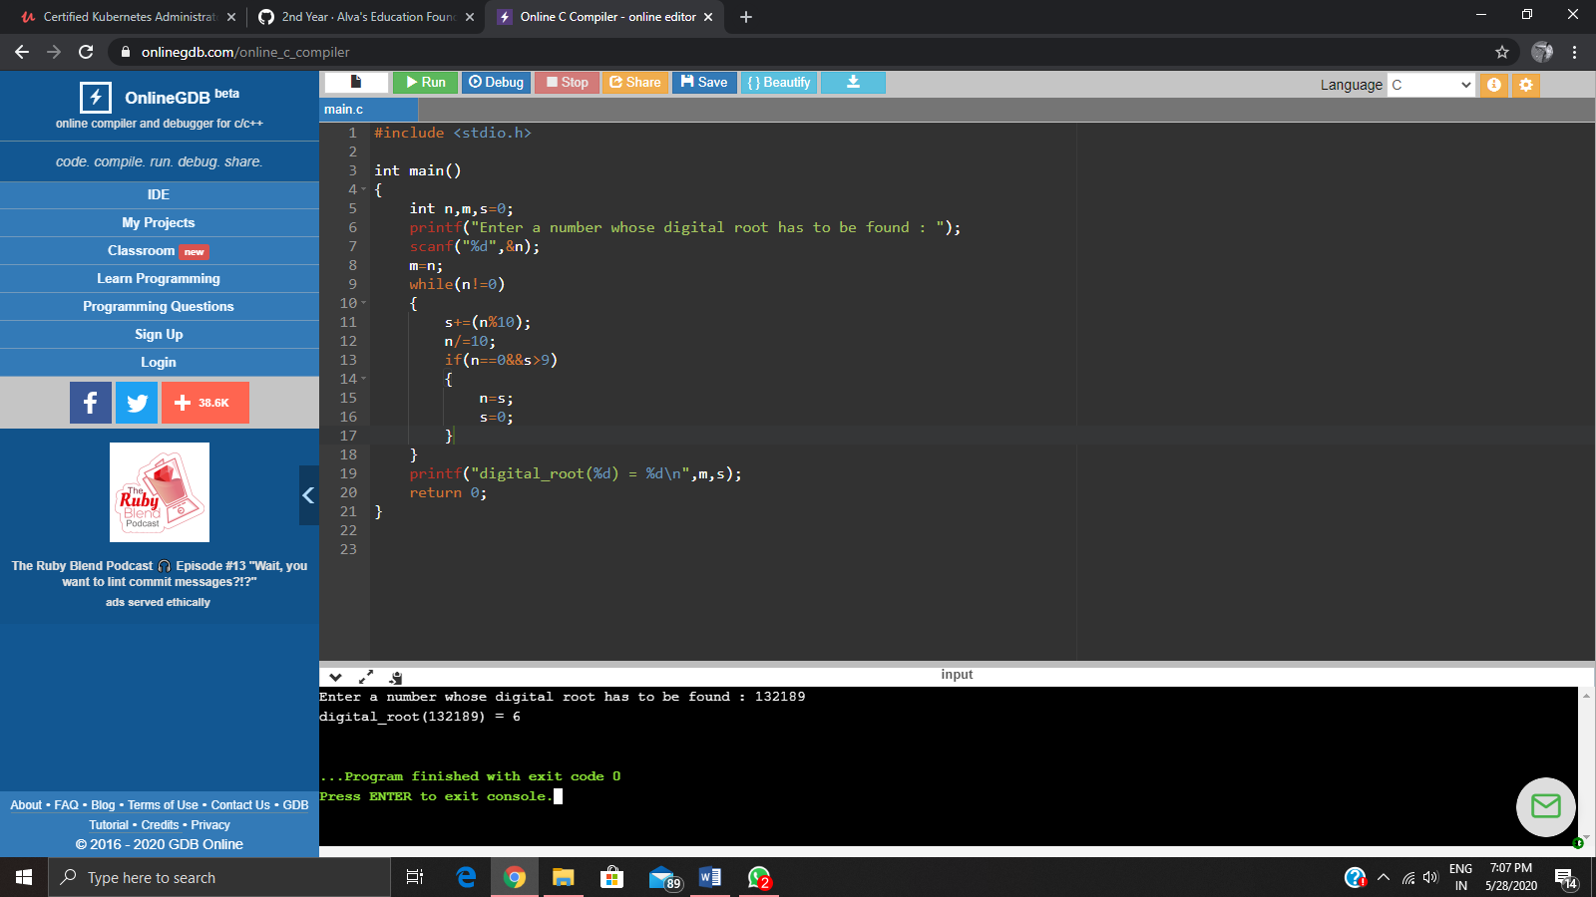

**Problem 2: (Using python) Write a program have to find the presence of vowels in all possible substrings of the given string. For each given string you have to print the total number of vowels.**

